|  |  |  |  |  |  |
| --- | --- | --- | --- | --- | --- |
|  |  |  |  |  | logo1.png |

|  |  |  |  |
| --- | --- | --- | --- |
| Course Name | | Zoho Books | |
| College Name | | Mangayarkarasi College of Arts and Science for Women Paravai, Madurai - 625002 | |
| College Code | | MKU251 | |
| Skill Offering Id | |  | |
| Project Title | | Preparation and maintenance of zoho books for TravelTrax Tours | |
| Project Submitted To | | Madurai Kamaraj University ( Naan Mudhalvan Scheme(TNSDC)) | |
| Year | | 2023 | |
| Department | | B.COM | |
| Semester | | 5 | |
| Group Number | | | NM2023TMID37121 |  |  | | --- | --- | --- | | |
| Totalmbers of the Group | | 4 | |
| Group Members Details | | | |
| Name of the Member | University Register. No | | Student NM ID |
| N.Angeli | C1C15604 | | NM2023TMID37121//E5EF89CB00CA698AE4149D7D0CA0D642 |
| M.Jeyalakshmi | C1C15624 | | C068529447654A8A12F4E1E4EE2E222C |
| S.Dharani | C1C15613 | | 158554DE4189607A2EC475A0103F1E60 |
| P.Dhanasri | C1C15611 | | 5A35D9B14D570B2953C40724B429A48F |
|  |  | |  |
| Under the Guidance | | R.Anu | |
| SPOC | | Ms.P.UMADEVI | |

**Preparation and Maintanence of ZOHO Books for TravelTrax Tours**

**1.1 Introduction:**

**TravelTrax Tours, a tour operator, leverages Zoho Books to manage their bookings, track expenses,**

**and handle invoicing for their customers. They can generate professional invoices, reconcile payments,**

**and monitor their financial performance. Zoho Books helps them streamline their financial operations**

**and enhance customer service.**

**1.2 Propose:**

**Analysing housing prices in metropolitan areas in India is a complex and multifaceted topic. Here’s a breif description, Housing Prices can vary significantly across differentt metropolitan areas, with cities like Mumbai, Delhi, and Bangalore often having higher real estate costs compared to smaller metros. In Summary, ana housing prices in Indian metropolitan areas involves examining the complex interplay of economic, socil and policy factors that impact the real estate market, making it a vital area of study and concern for both residents and investors.**

1. **Problem Definition and Design Thinking**
   1. Empathy Map

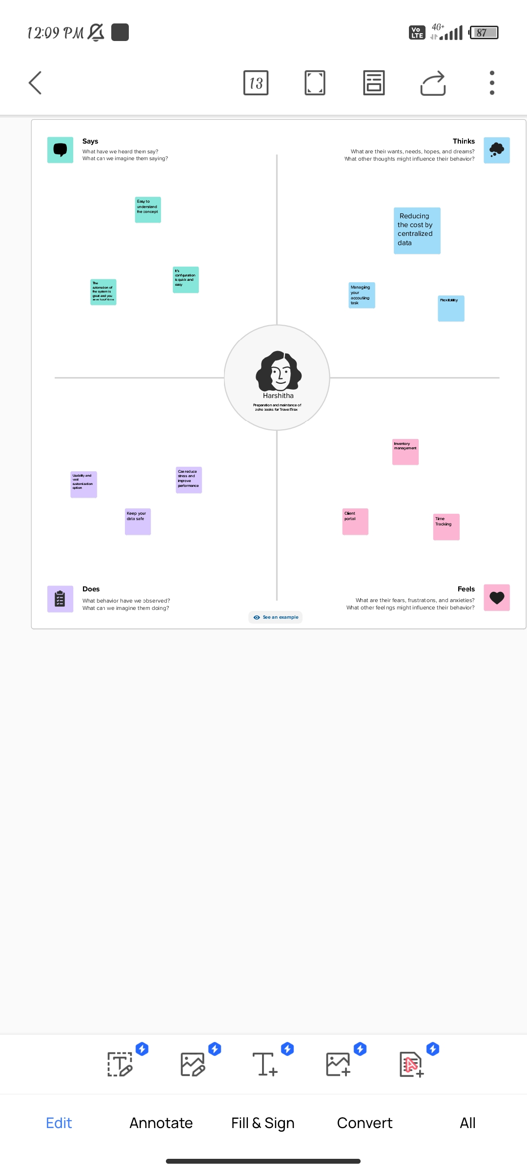

**2.2 Ideation and Brainstroming Map**

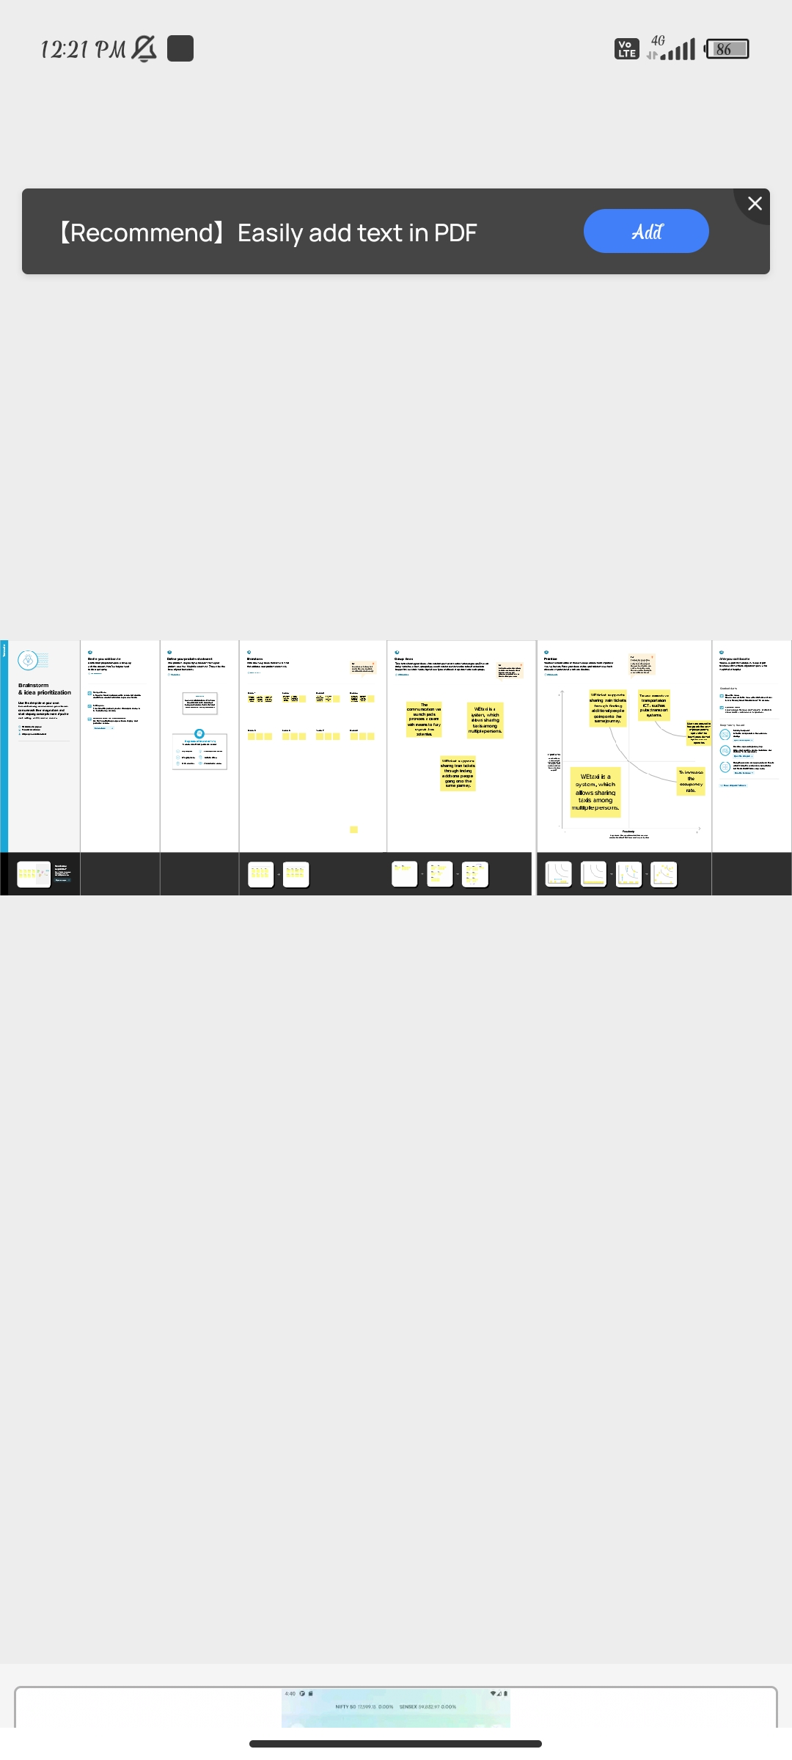

***Milestone 1: Set up your accounts***

***Activity 1: Sign up for a Zoho Books account and Login***

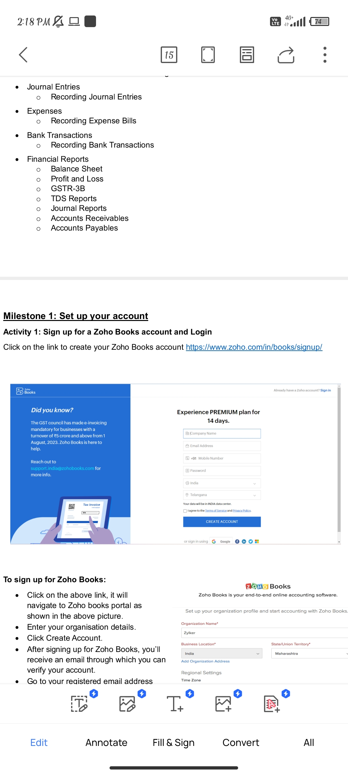

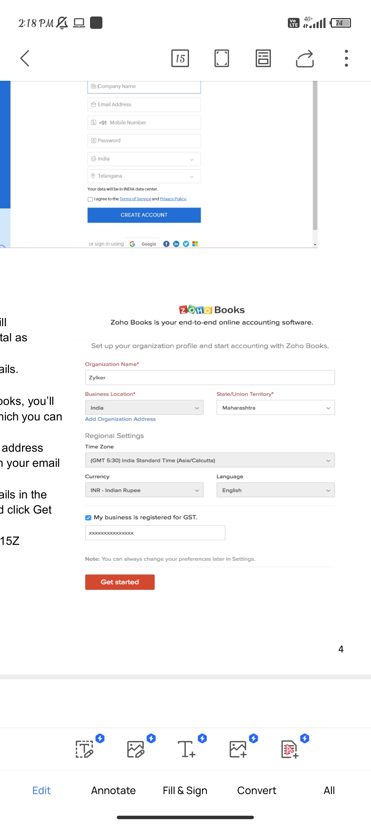

***Milestone 2: Service Creation:***

***Activity 1: Creation***

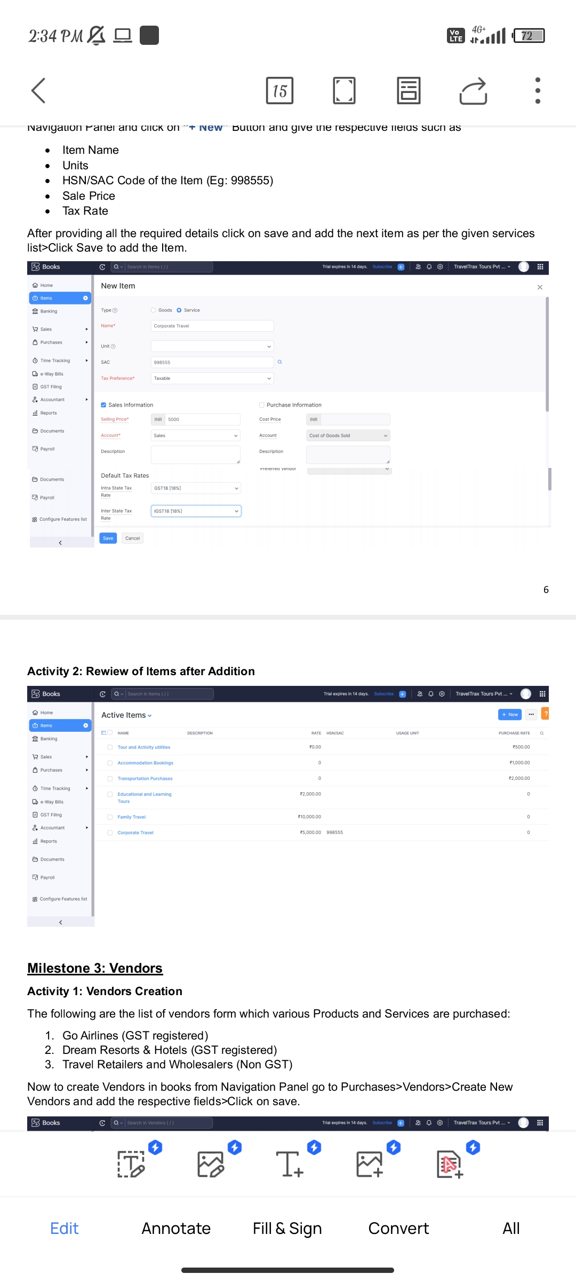

***Activity 2: Rewiew of Items after Addition***



***Milestone 3: Vendors***

***Activity 1: Vendors Creation***

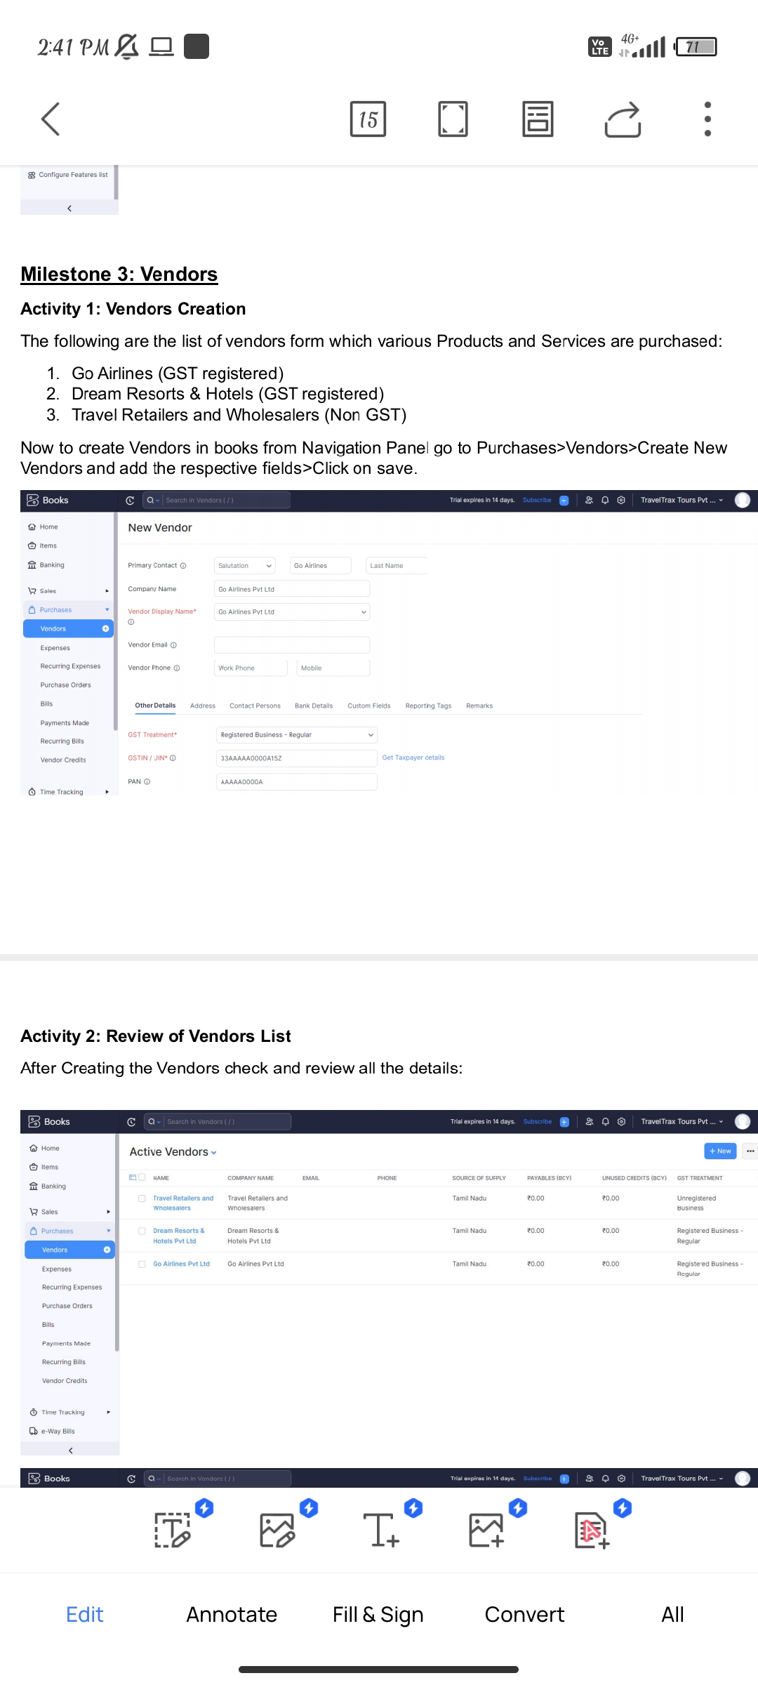

***Activity 2: Purchase Order to Purchase Bills Convertion***

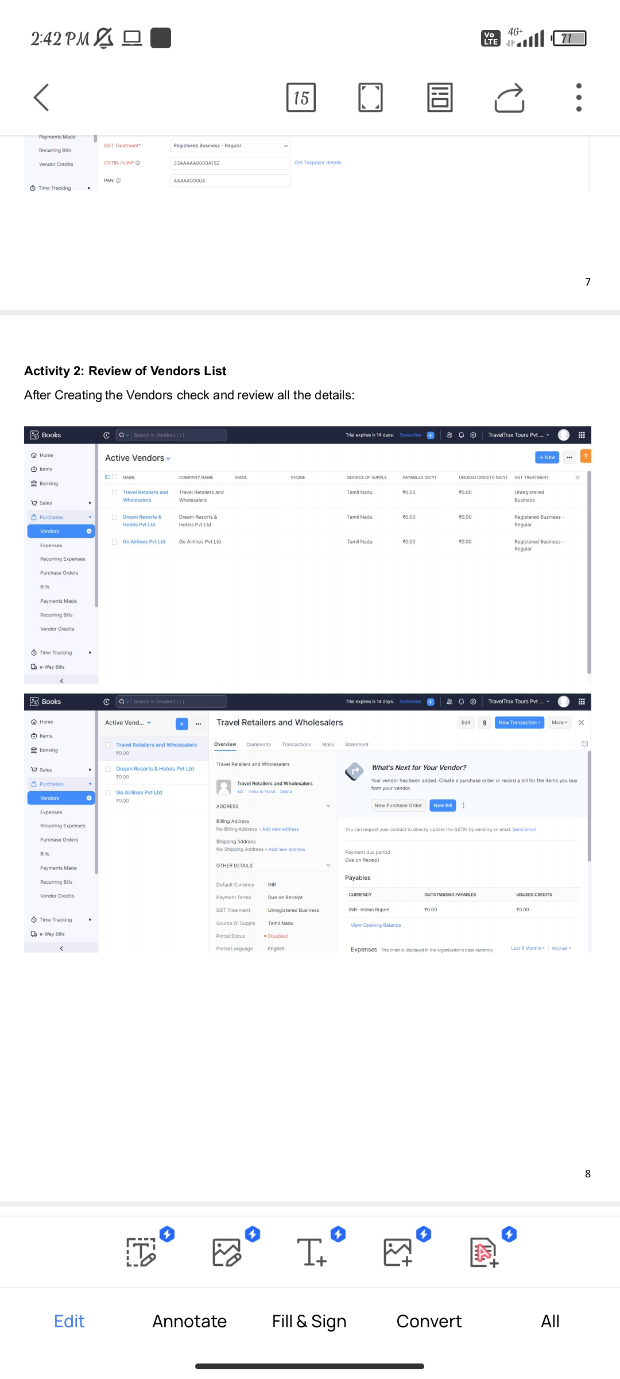

***Milestone 4: Purchases***

***Activity 1: Purchase Order Creation***

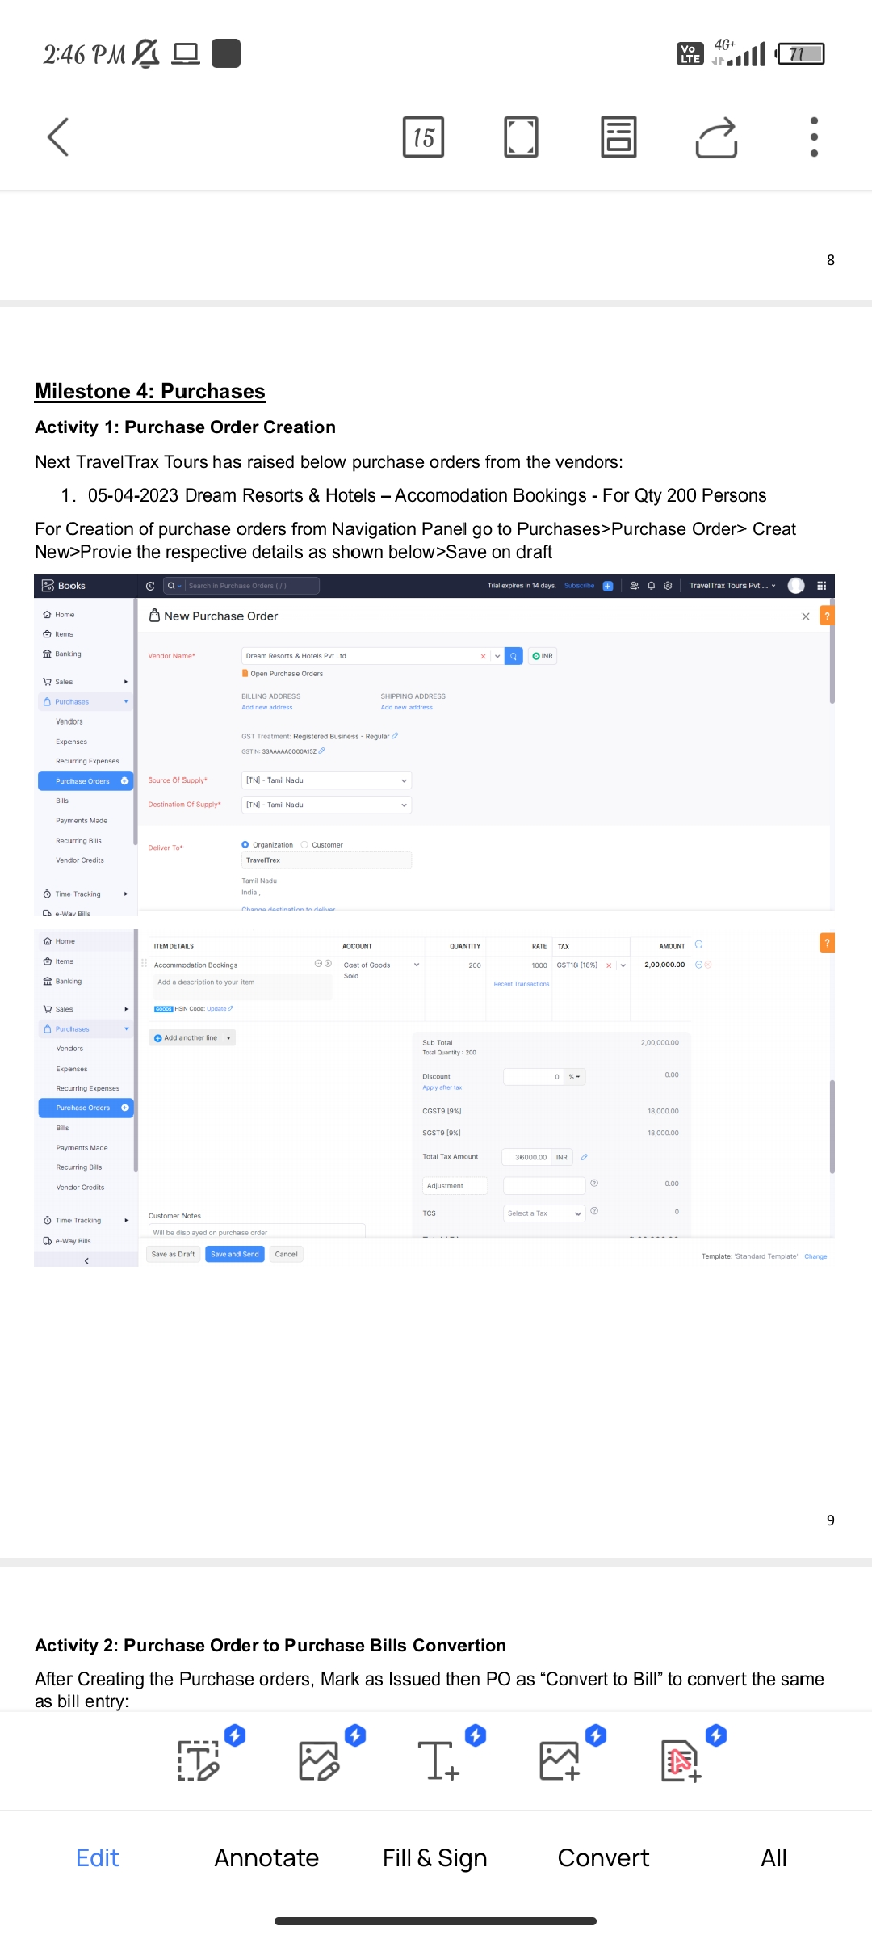

***Activity 2: Purchase Order to Purchase Bills Convertion***

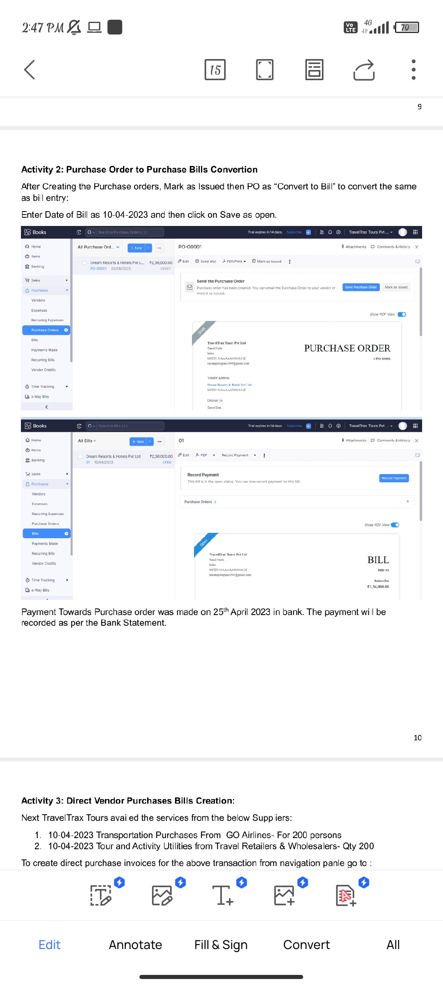

***Activity 3: Direct Vendor Purchases Bills Creation:***

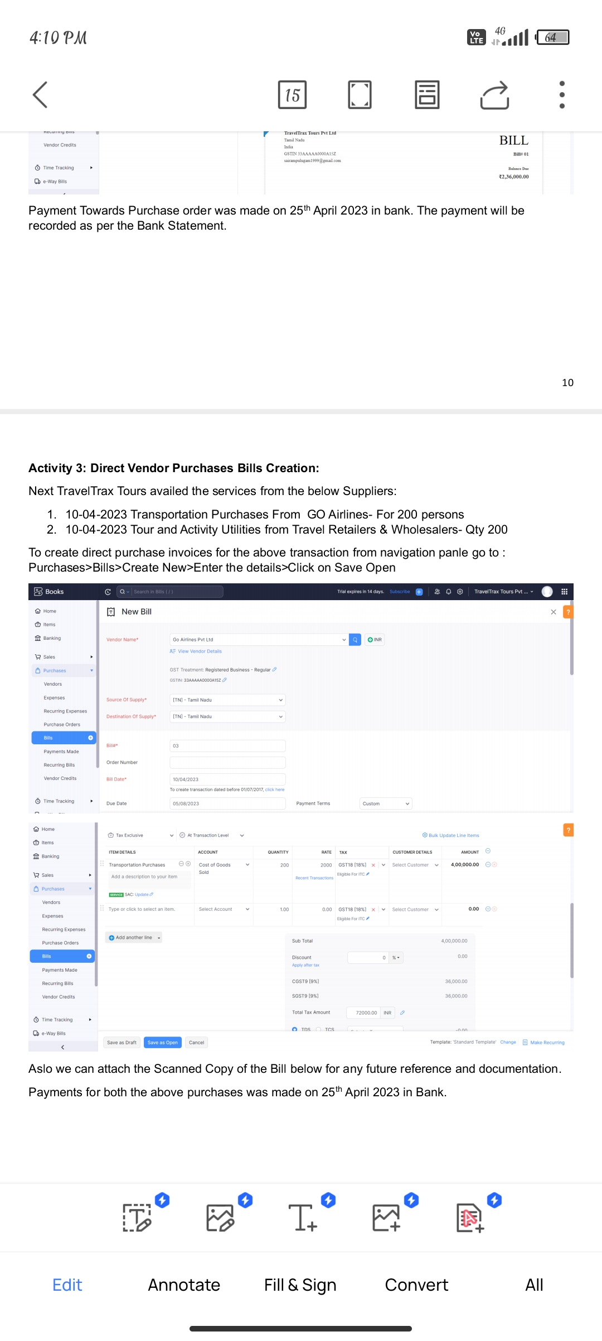

***Activity 4: Reconciliation of Open & Outstanding Bills***

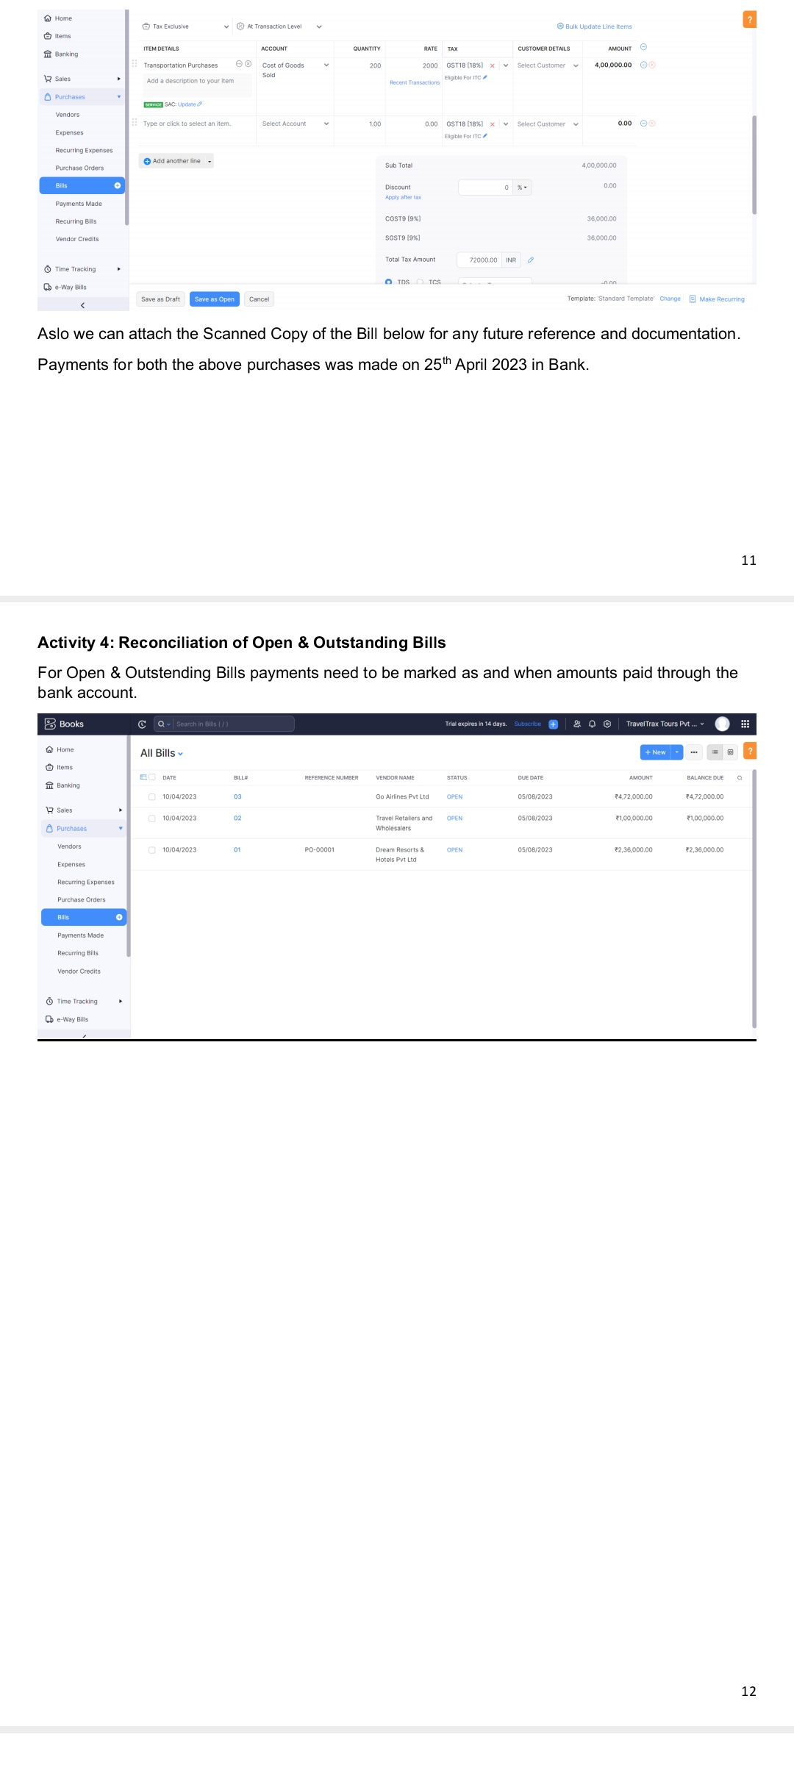

***Milestone 5: Customers***

***Activity 1: Customers Creation:***

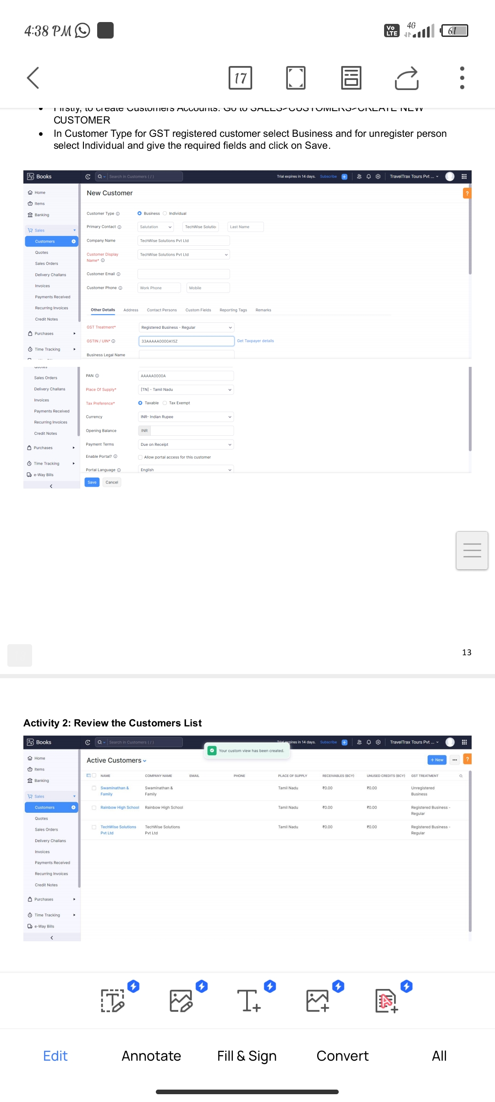

***Activity 2: Review the Customers List***

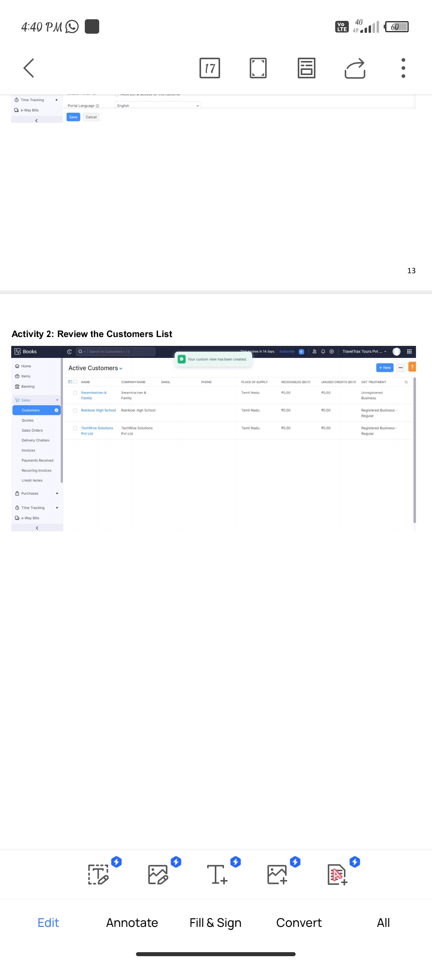

Milestone 6: Sales

Activity 1: Sales Order Creation

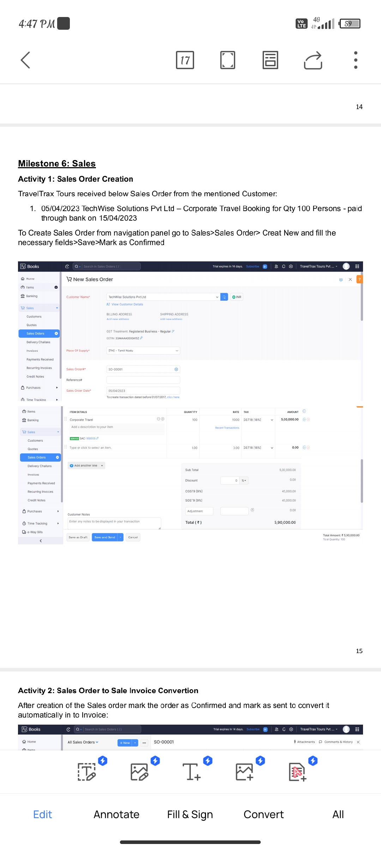

Activity 2: Sales Order to Sale Invoice Convertion

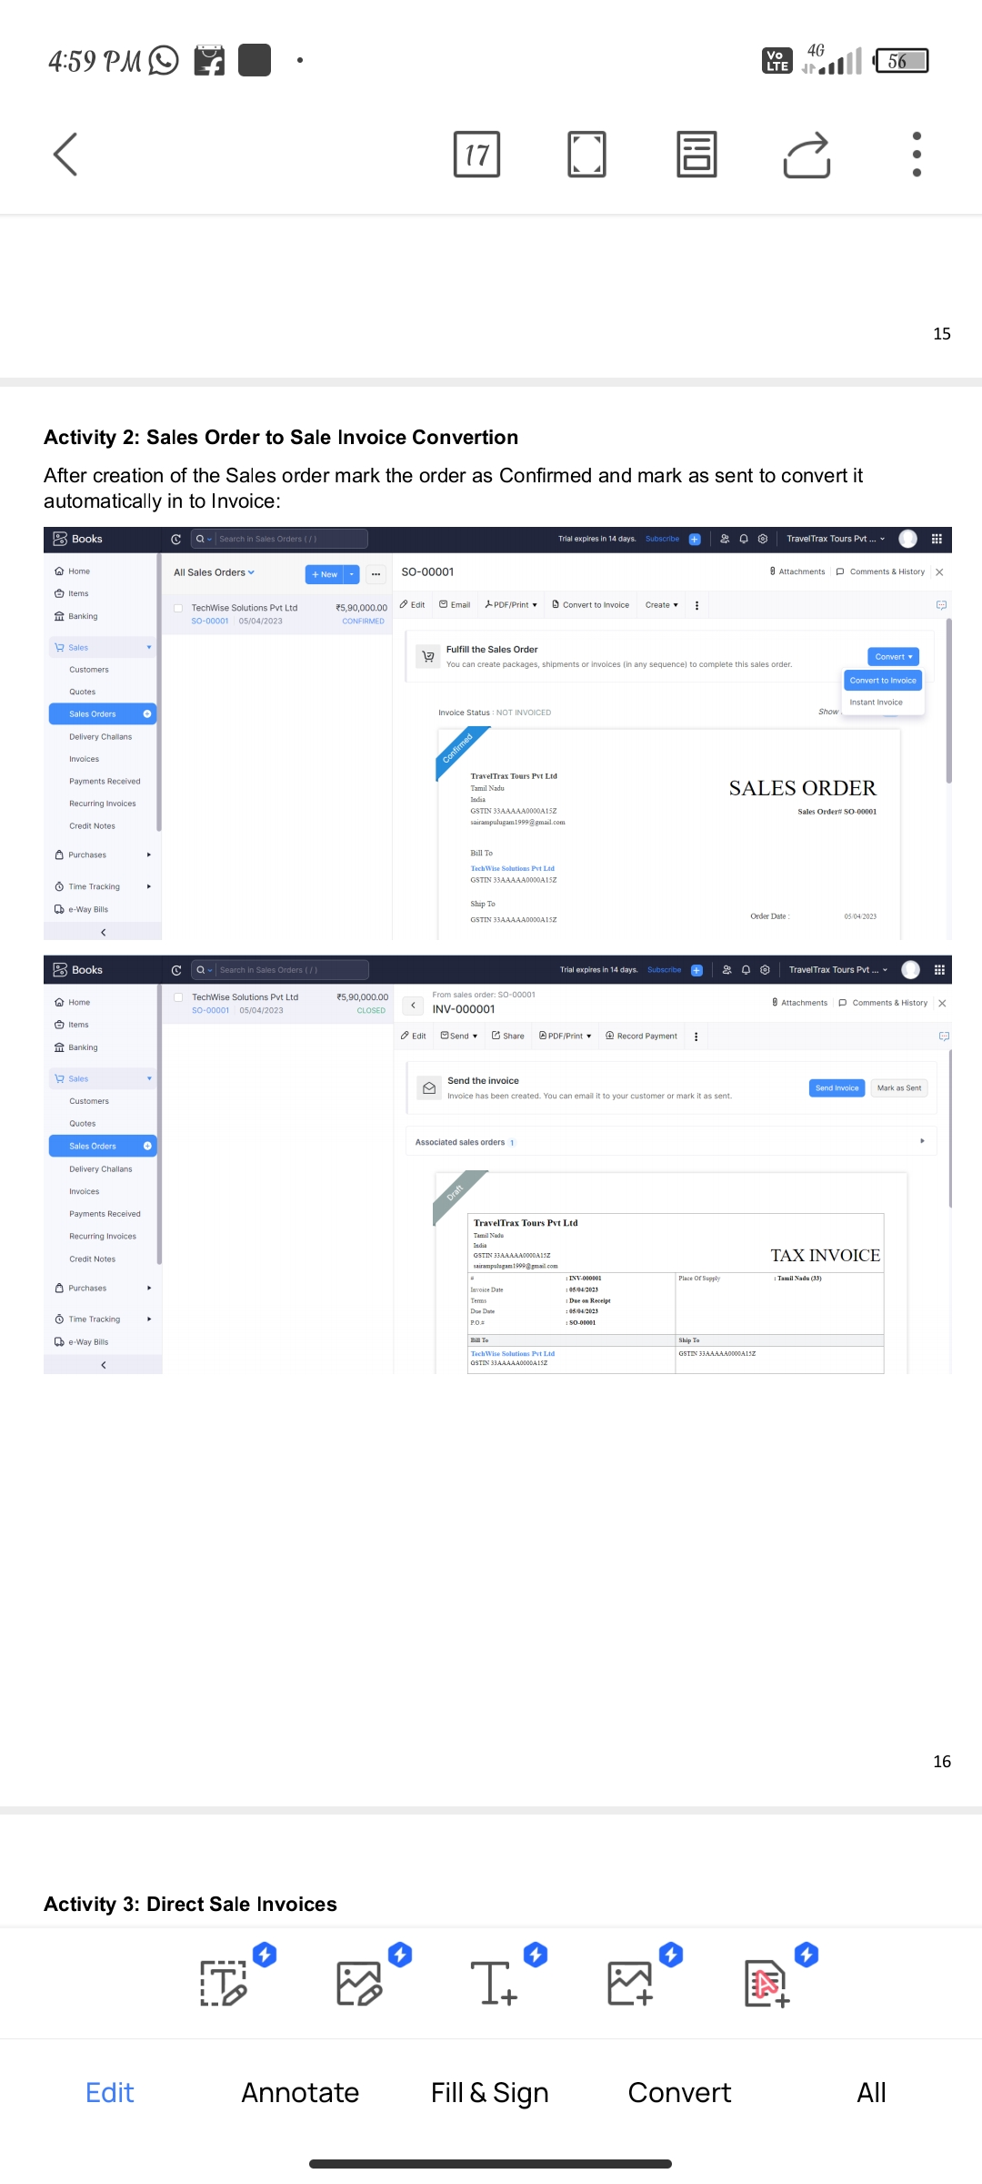

Activity 3: Direct Sale Invoices

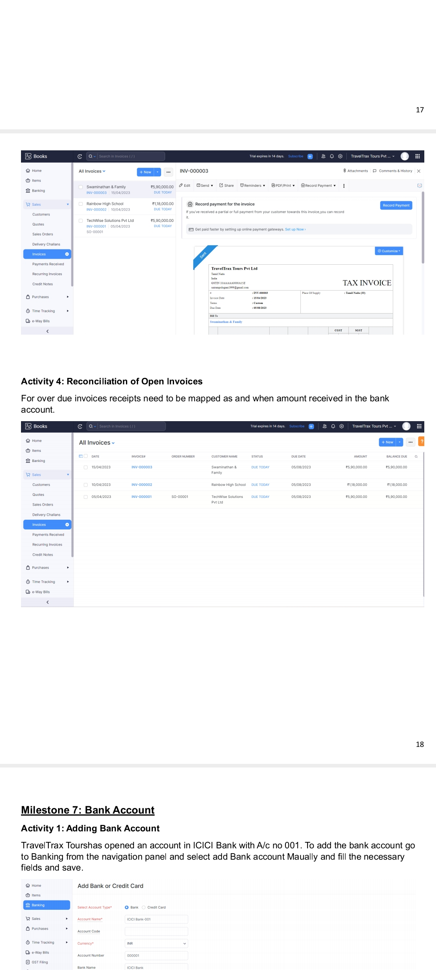

Activity 4: Reconciliation of Open Invoices

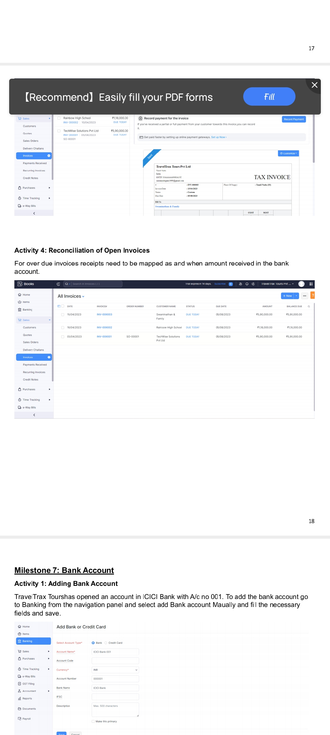

Milestone 7: Bank Account

Activity 1: Adding Bank Account

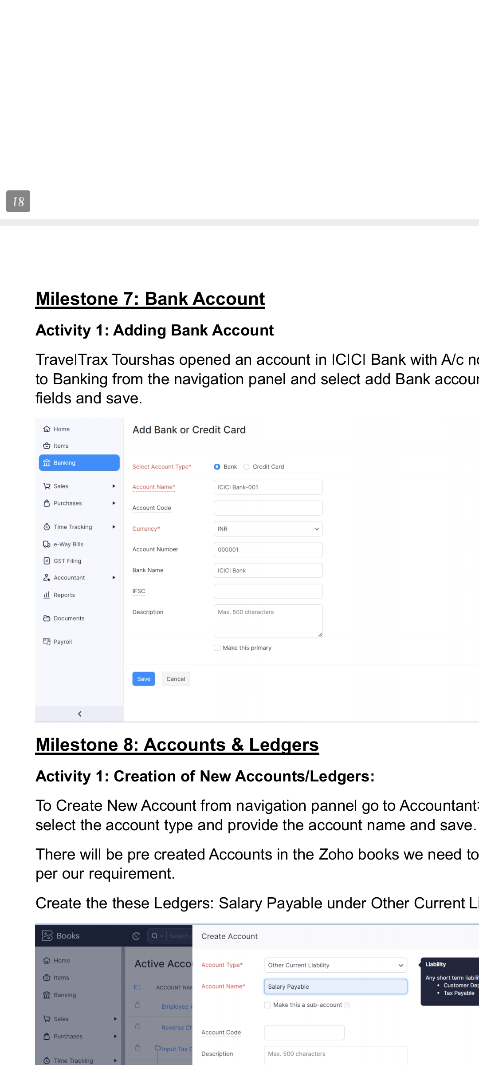

Milestone 8: Accounts & Ledgers

Activity 1: Creation of New Accounts/Ledgers:

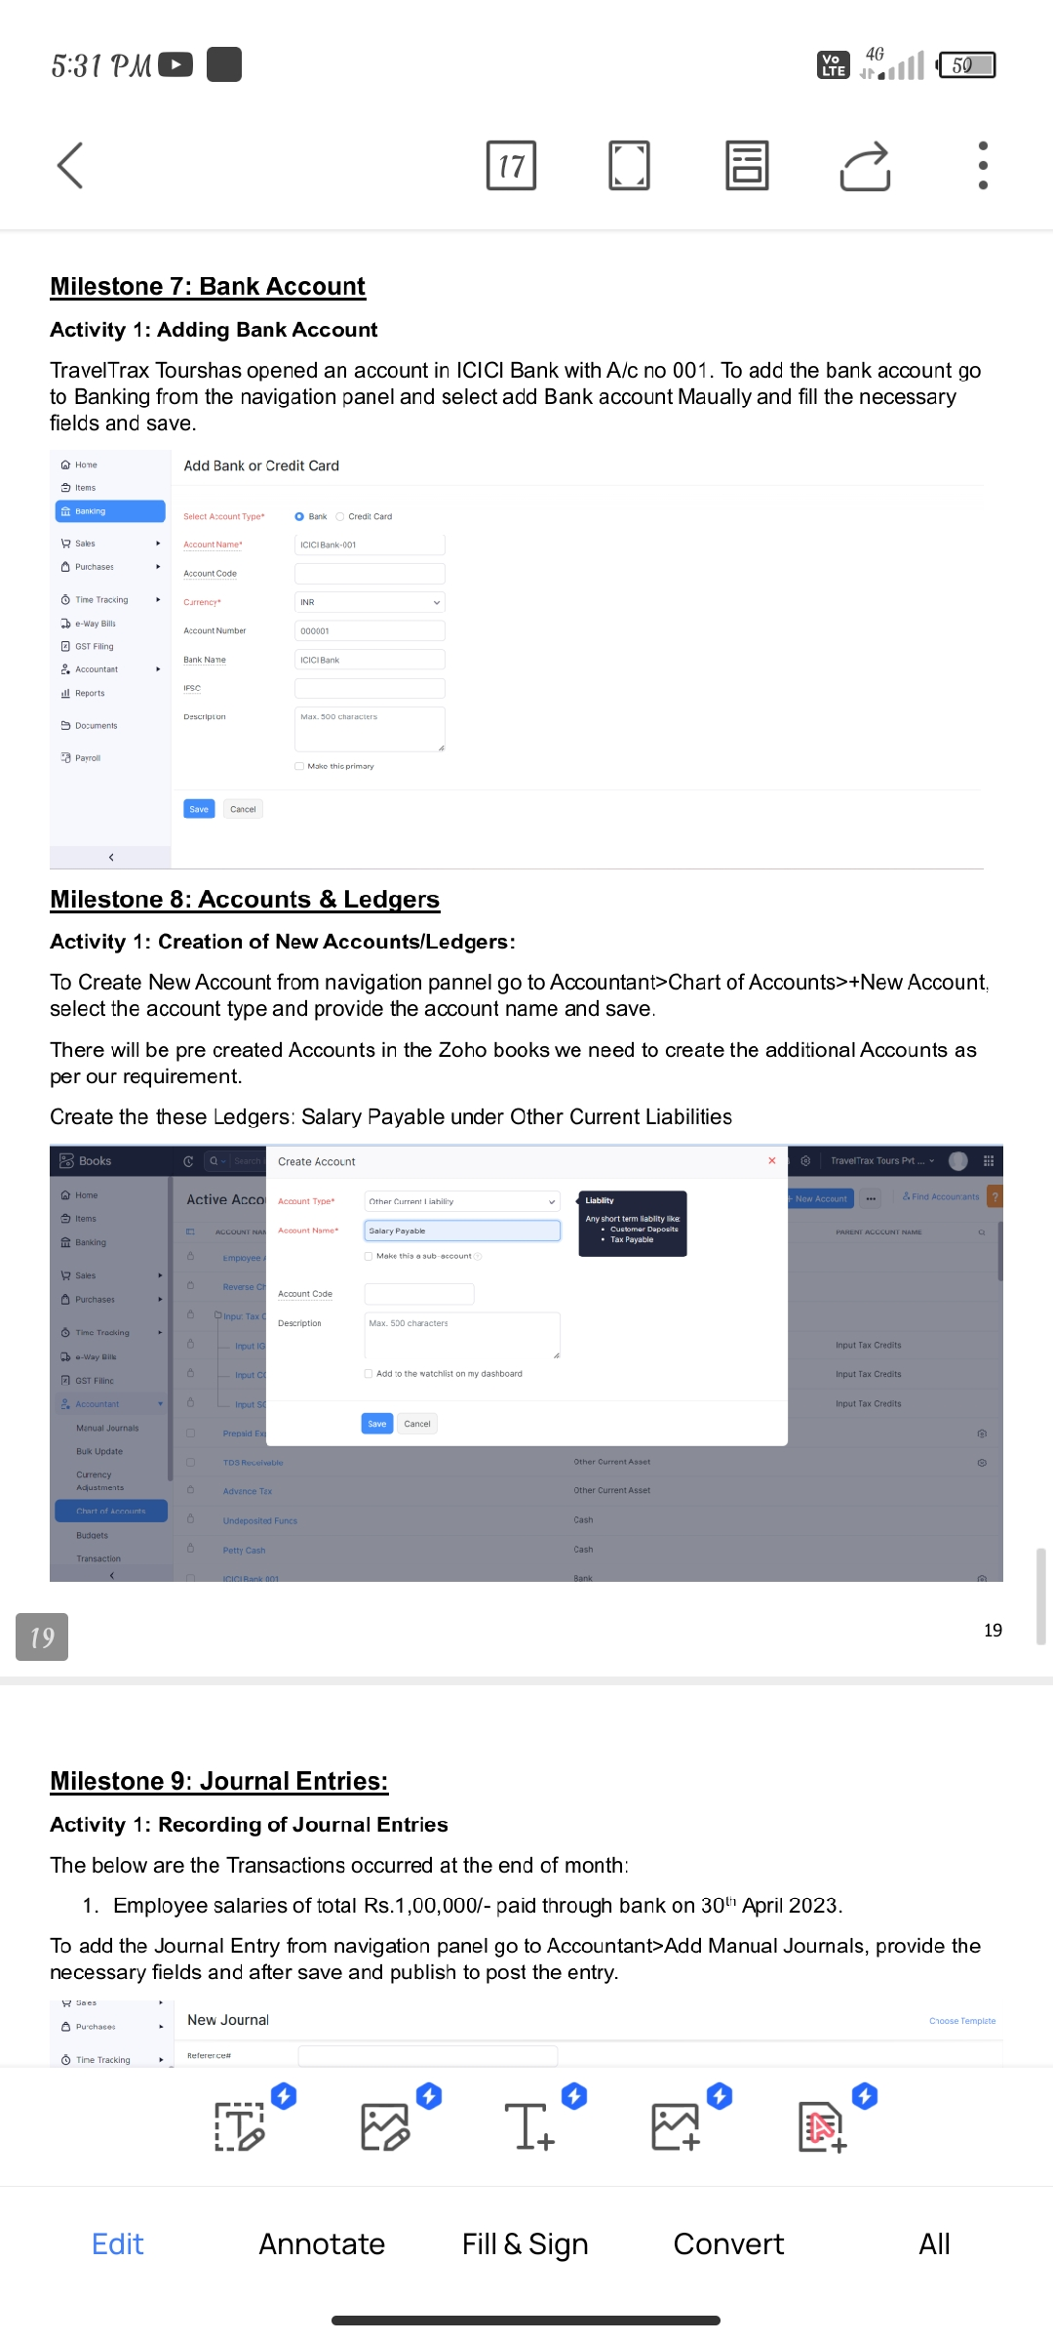

Milestone 9: Journal Entries:

Activity 1: Recording of Journal Entries

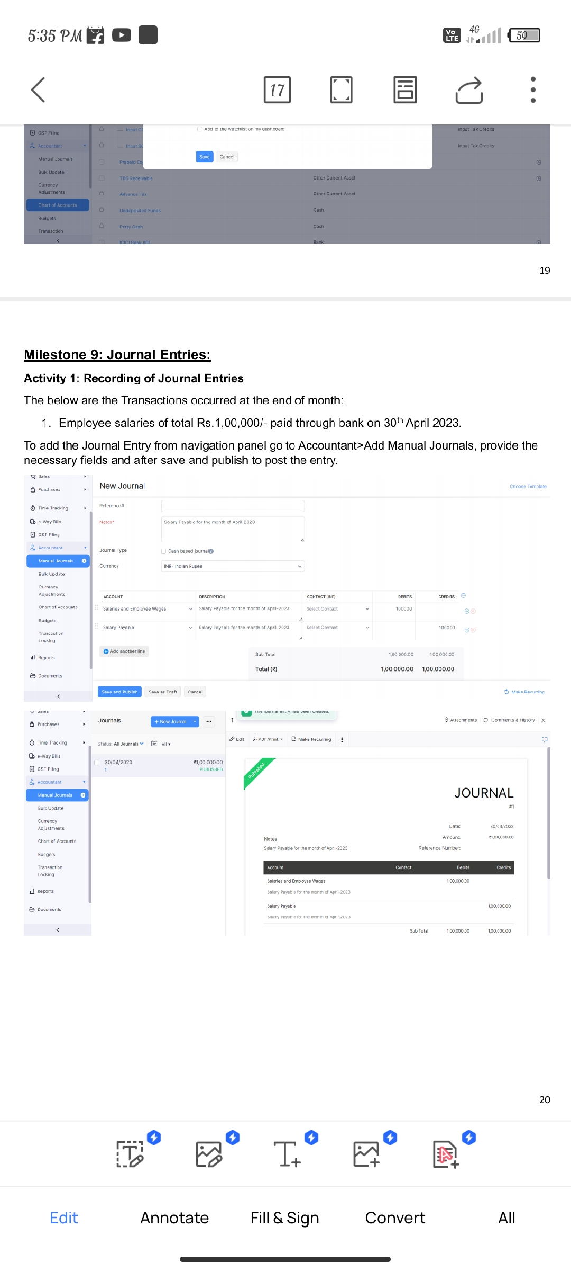

Milestone 10: Expense & Bills

Activity 1: Expense & Bills Entry

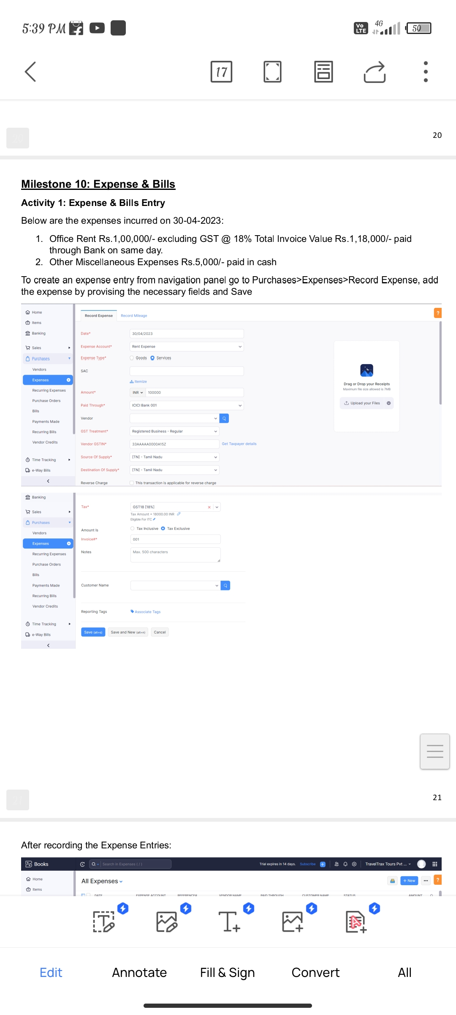

After recording the Expense Entries:

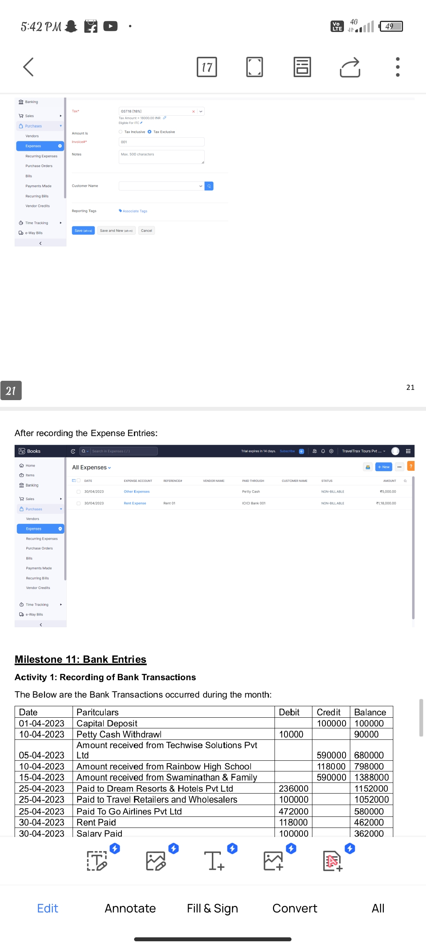

Milestone 11: Bank Entries

Activity 1: Recording of Bank Transaction

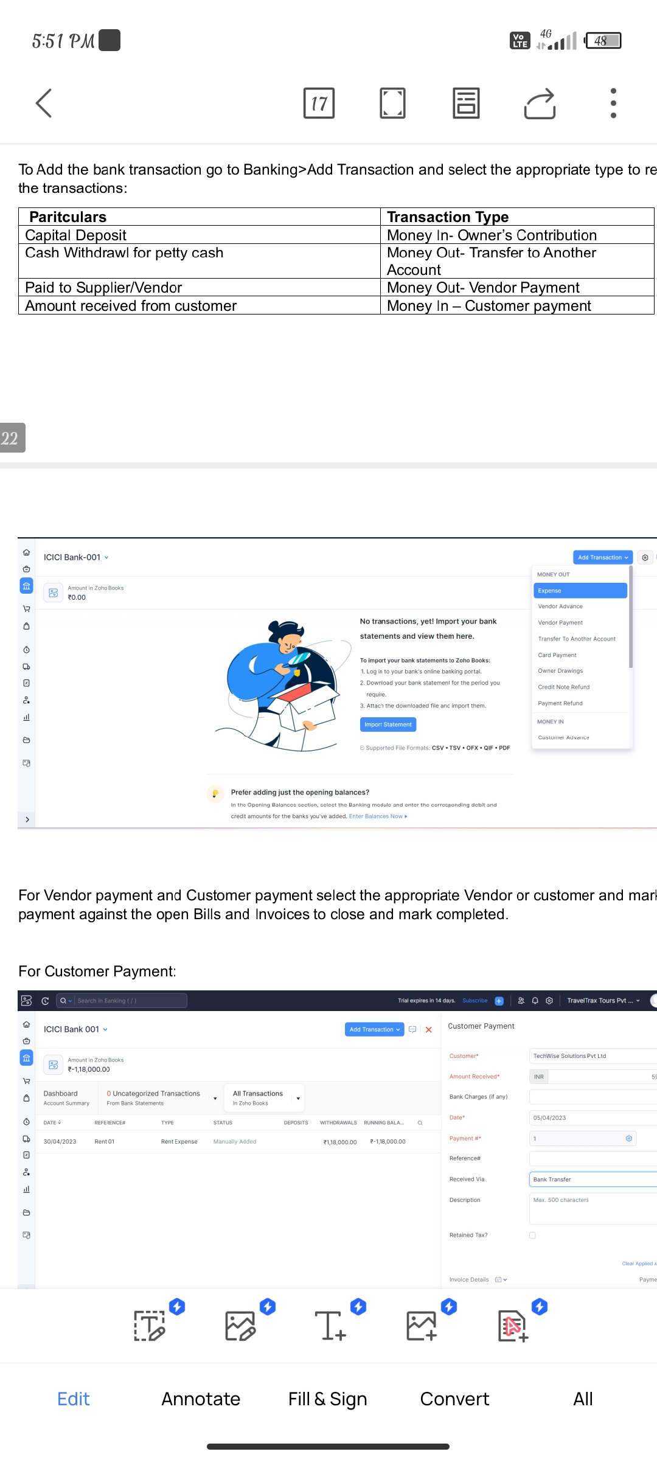

For Customer Payment:

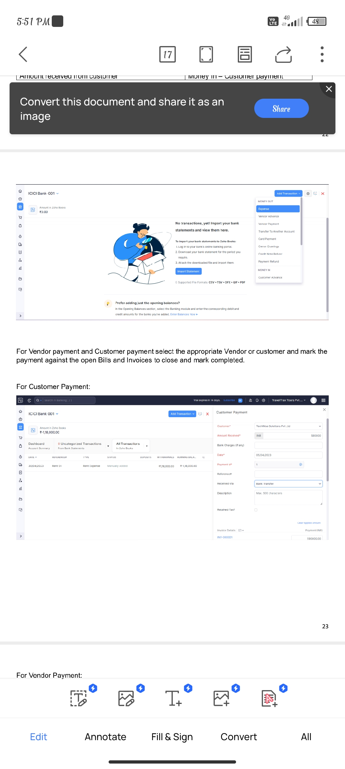

For Vendor Payment:

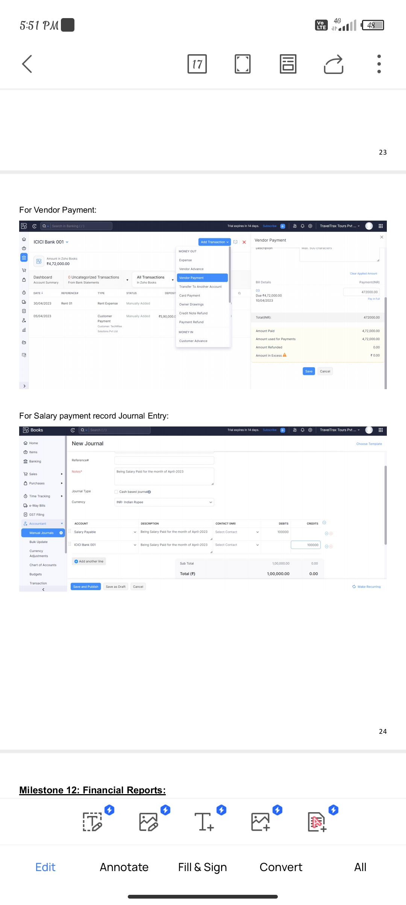

For Salary payment record Journal Entry:

Milestone 12: Financial Reports:

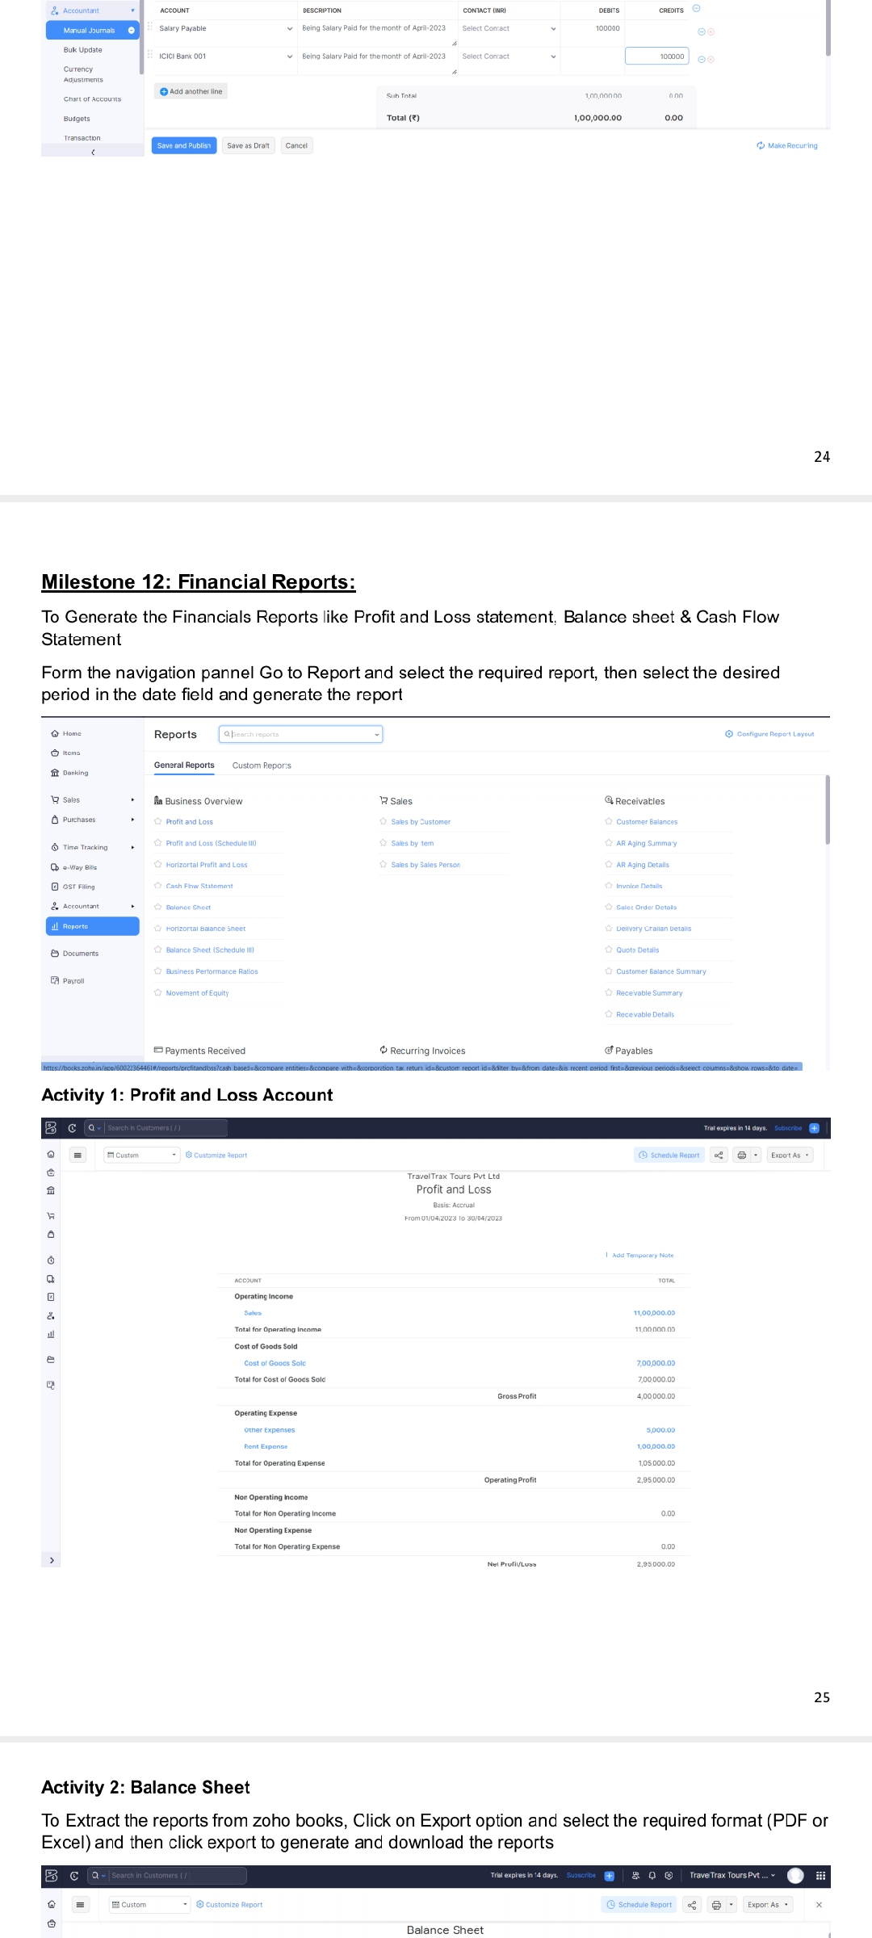

Activity 1: Profit and Loss Account



Activity 2: Balance Sheet

Activity 3: GST Report

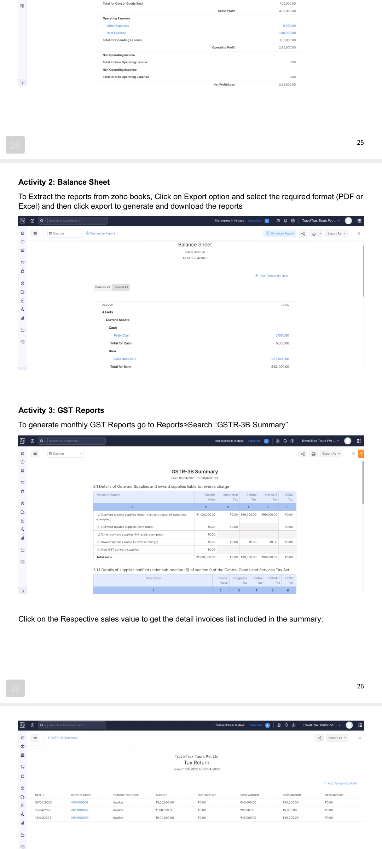

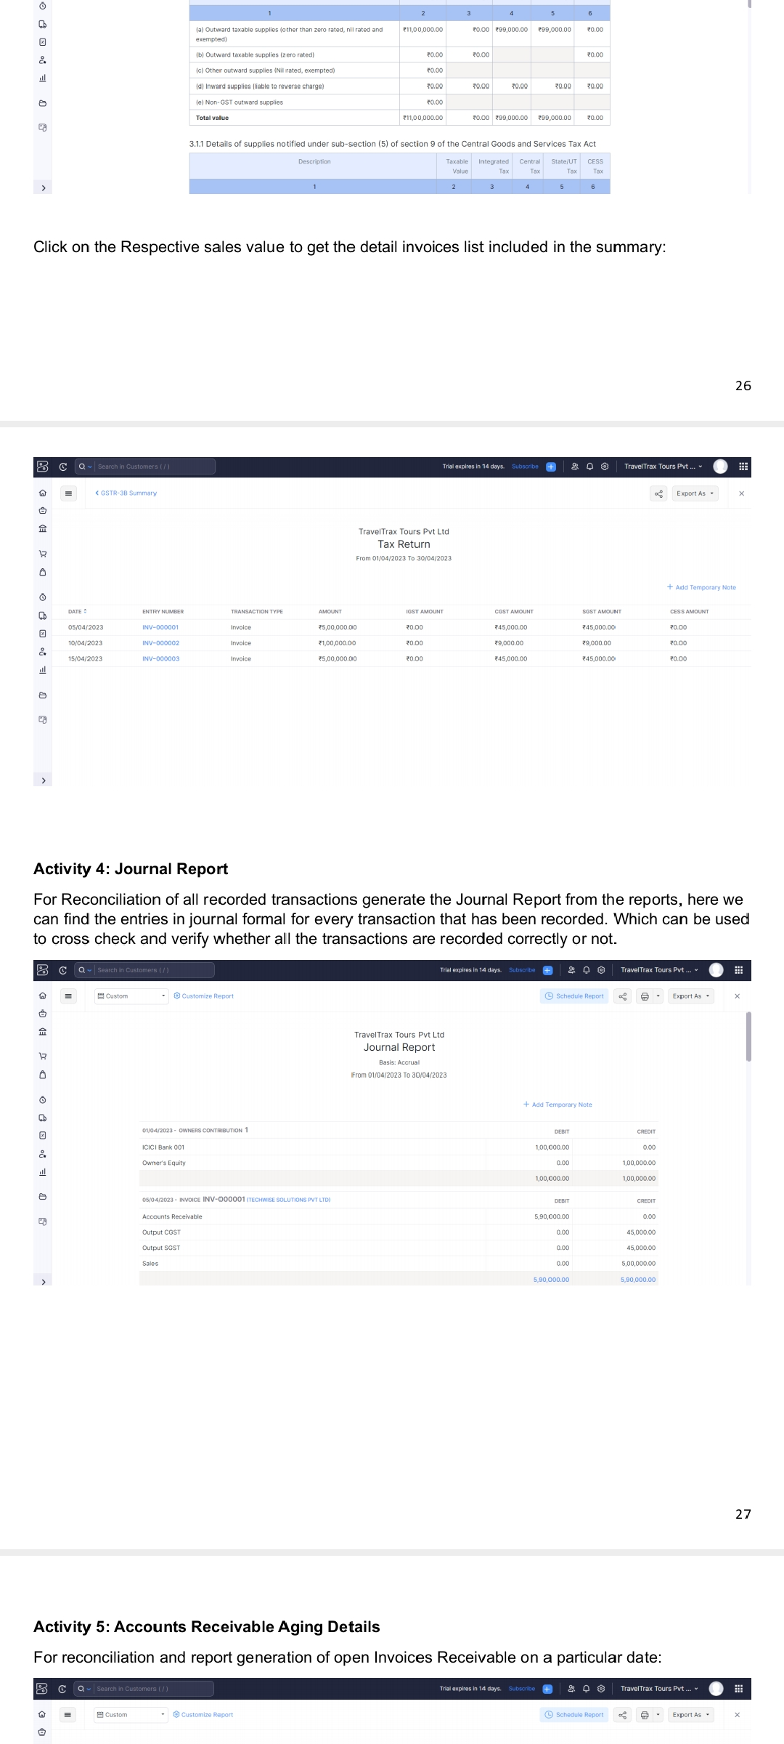

Activity 4: Journal Report



Activity 5: Accounts Receivable Aging Details

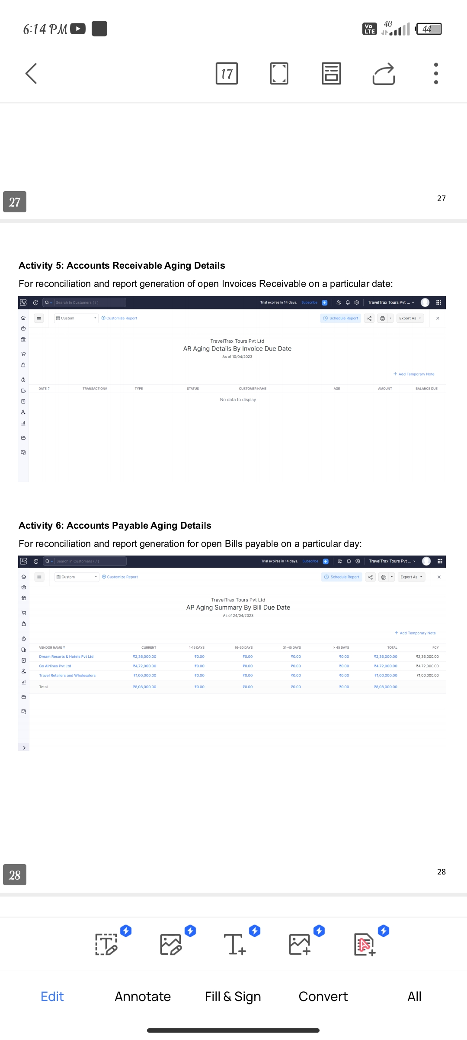

Activity 6: Accounts Payable Aging Details